Project Design Phase-II
Data Flow Diagram & User Stories

Date | 26 October 2026
Team ID
Project Name | Electric Vehicle Market Performance & Insights
Maximum Marks | 4 Marks

Data Flow Diagrams:
A Data Flow Diagram (DFD) is a traditional visual representation of the information flows within a system. A neat and clear DFD can depict the right amount of the system requirement graphically. It shows how data enters and leaves the system, what changes the information, and where data is stored.
Project-specific DFD (CSV → Tableau → Published Website)
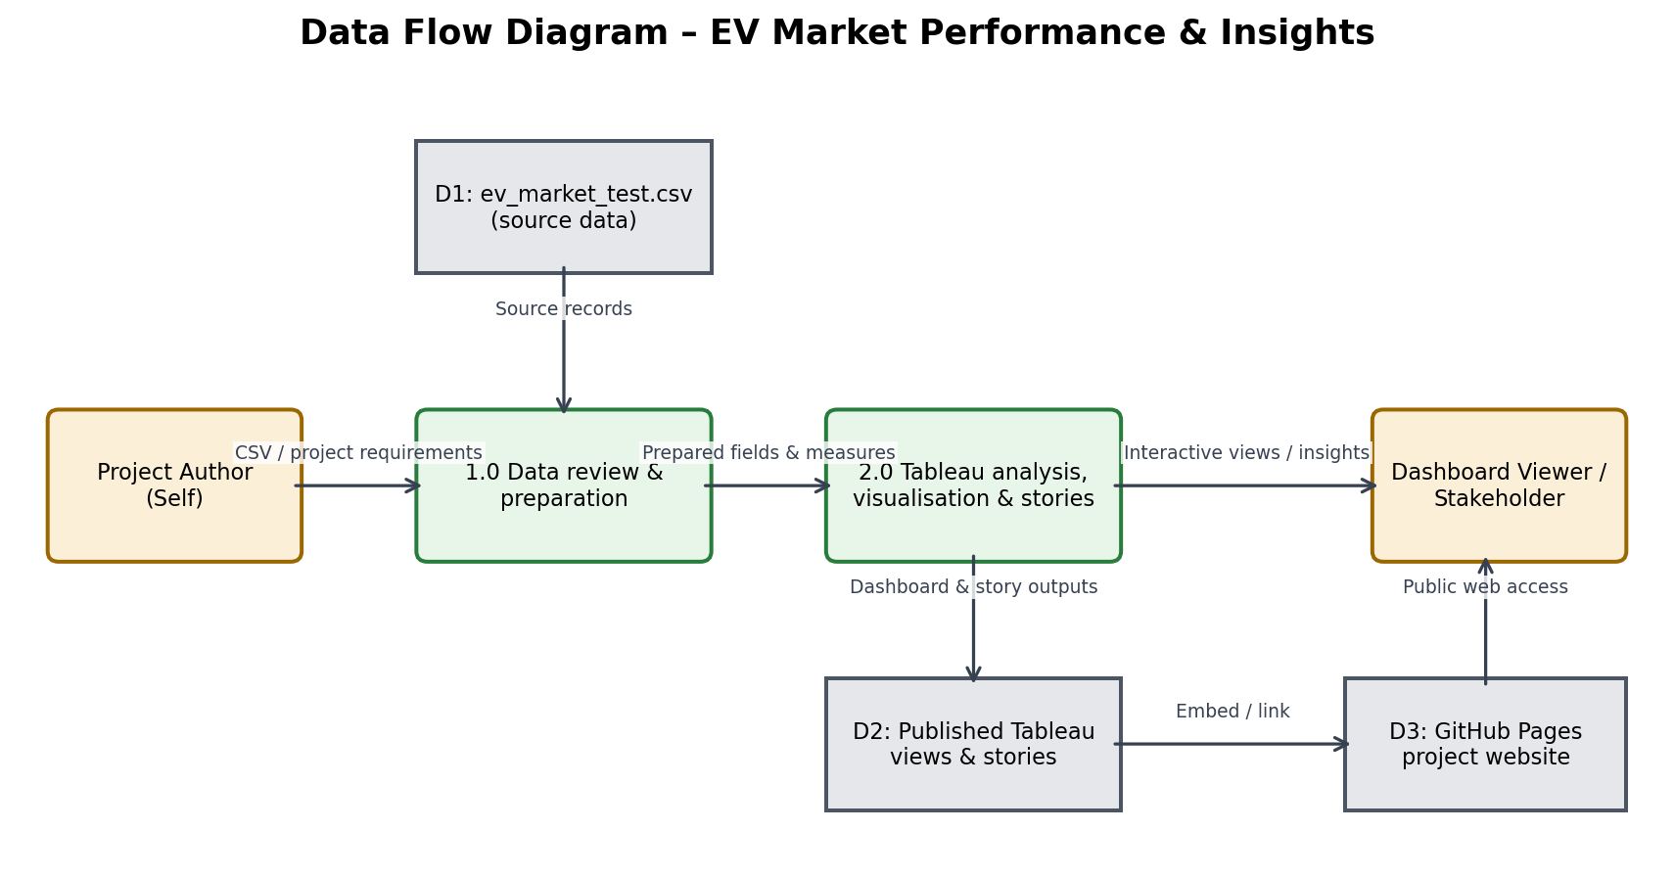
Figure 1. Data enters from the supplied CSV, is reviewed/prepared, analysed in Tableau, then published as dashboard/story views and linked from the GitHub Pages website.
DFD Symbol Legend
Symbol | Name | Description
Oval / Rounded  shape | External Entity | A person, organization, or system outside the project that sends or receives data (e.g., Customer, Payment Gateway).
Rectangle with  numbered header | Process | An activity that transforms incoming data into outgoing data (e.g., Validate Request, Process Order).
Rectangle (solid fill, no number) | Data Store | A place where data is held for later use (e.g., Customer Database, Inventory).
Labeled arrow | Data Flow | The movement of data between entities, processes, and data stores, labeled with what data is being passed.

Example: DFD Level 0 (Industry Standard)



User Stories
Use the below template to list all the user stories for the product.
User Type | Functional Requirement (Epic) | User Story Number | User Story / Task | Acceptance criteria | Priority | Release
Dashboard Viewer | Data Access | US-1 | As a viewer, I want to open the public EV project website and access the published dashboard. | The website loads and the dashboard link opens the public Tableau view. | High | Release 1
Dashboard Viewer | Market Overview | US-2 | As a strategy viewer, I want to compare recorded annual sales by manufacturer. | The chart displays summed annual_sales_units by manufacturer and can be sorted/filtered. | High | Release 1
Dashboard Viewer | Battery Analysis | US-3 | As a viewer, I want to see the distribution of vehicle records by battery technology. | The visualisation groups distinct vehicle records by battery_type and labels the measure as dataset records, not market share. | High | Release 1
Dashboard Viewer | Range Analysis | US-4 | As a viewer, I want to compare average driving range across manufacturers. | The chart displays AVG(range_km) for the selected manufacturers and clearly identifies kilometres. | High | Release 1
Dashboard Viewer | Technology Analysis | US-5 | As a viewer, I want to explore the relationship between battery capacity and driving range. | The scatter plot uses battery_capacity_kwh and range_km, with battery type available for visual distinction. | High | Release 1
Dashboard Viewer | Geographic Analysis | US-6 | As a viewer, I want to compare vehicle-record counts by manufacturing country. | The chart/map groups distinct vehicle records by manufacturing_country and does not describe counts as factory output. | Medium | Release 1
Dashboard Viewer | Customer Insights | US-7 | As a viewer, I want to compare average customer ratings by manufacturer. | The chart calculates average available customer_rating values and does not treat missing ratings as zero. | High | Release 1
Dashboard Viewer | Battery Analysis | US-8 | As a viewer, I want to compare average battery capacity across battery technologies. | The chart displays AVG(battery_capacity_kwh) by battery_type with kWh units. | Medium | Release 1
Dashboard Viewer | Sales Trend | US-9 | As a viewer, I want to examine recorded annual sales by model year. | The chart groups SUM(annual_sales_units) by model_year and labels it as model-year analysis, not transaction-year sales. | Medium | Release 1
Dashboard Viewer | Interactive Filtering | US-10 | As a viewer, I want to filter the dashboard by manufacturer, model year, battery type and manufacturing country. | Available filters update the relevant dashboard views consistently; category filter is included only if the field exists in the source. | High | Release 1
Dashboard Viewer | Storytelling | US-11 | As a viewer, I want to open the EV Market Performance story and follow its analytical sequence. | The published Story 1 URL opens the EV Market Performance story on Tableau Public. | High | Release 1
Dashboard Viewer | Storytelling | US-12 | As a viewer, I want to open the EV Technology and Customer Insights story. | The published Story 2 URL opens the technology and customer insights story on Tableau Public. | High | Release 1
Project Author (Self) | Publishing & Documentation | US-13 | As the project author, I want to publish the Tableau dashboard and stories and link them from the public website and repository. | The public website contains working dashboard/story links and the repository contains project documentation. | High | Release 1

Scope note: This is a public Tableau analytics website, not an account-based application. Registration, login, email confirmation, Facebook/Gmail authentication and customer-care workflows from the generic sample are not applicable and have not been claimed. Release 1 refers to the delivered capstone scope, not a formally scheduled sprint.
Data interpretation note: The supplied ev_market_test.csv is treated as a test dataset. Country and battery-type counts are record distributions; model-year sales are grouped by model_year; chart associations do not establish causation.

